**Postman Test Results**

1/ Running the server

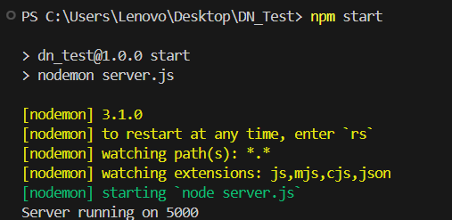

2/ Testing EndPoint : POST /api/savefullname

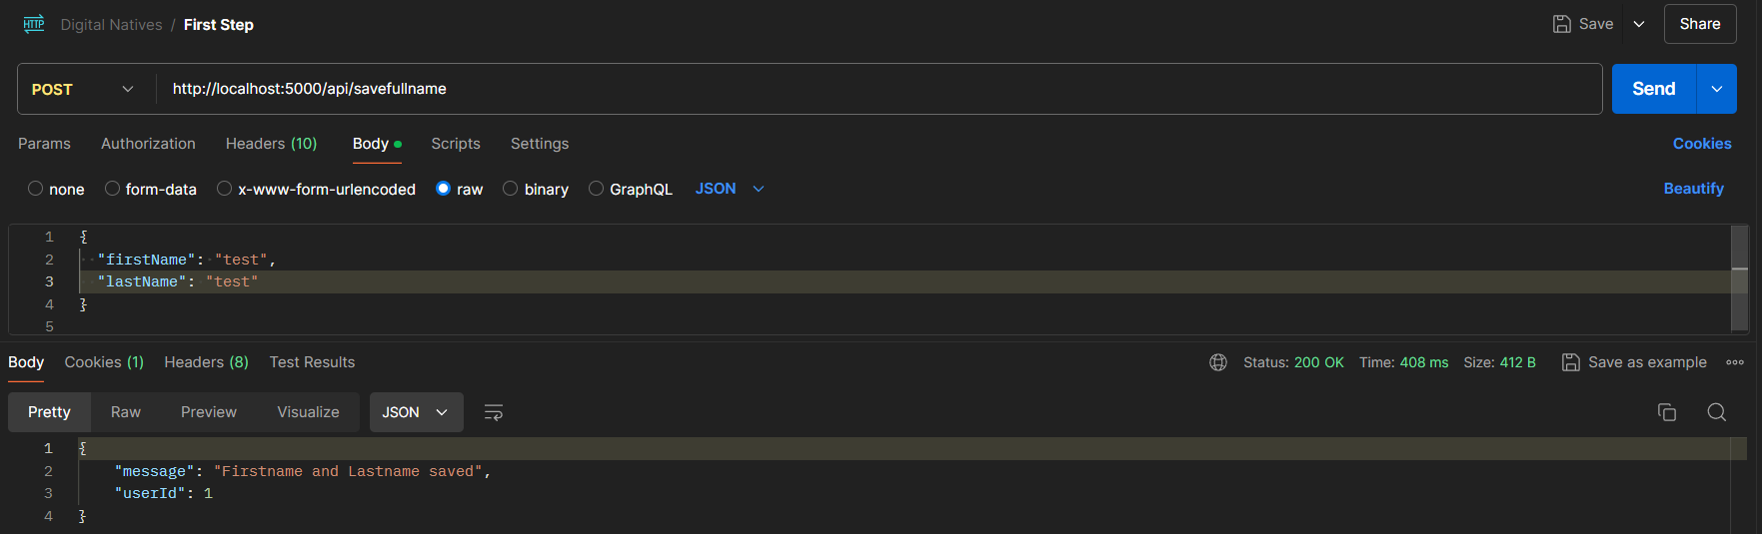

**SessionID**



**Saved in Database**

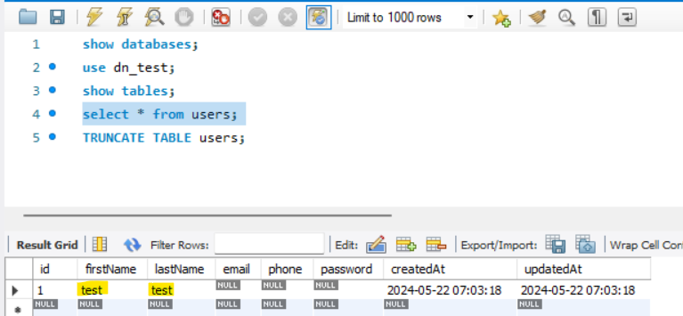

3/ Testing EndPoint : POST /api/savefullname

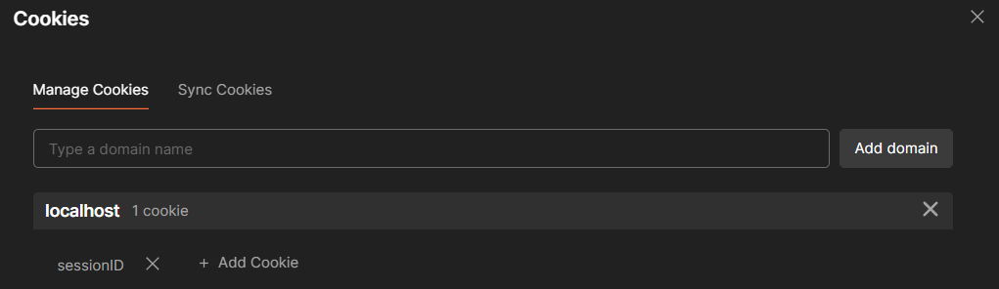

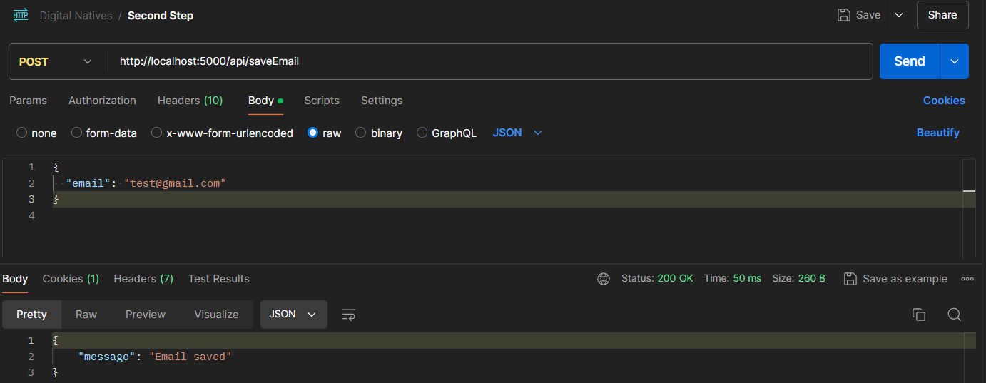

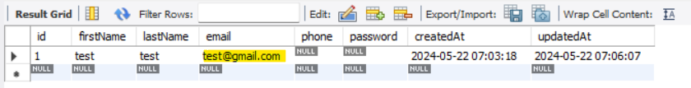

4/ Testing EndPoint : POST /api/savePhone

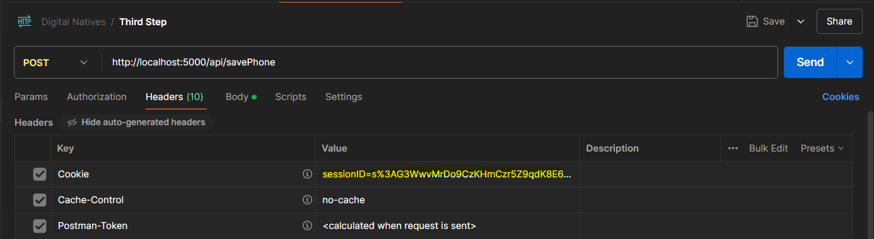

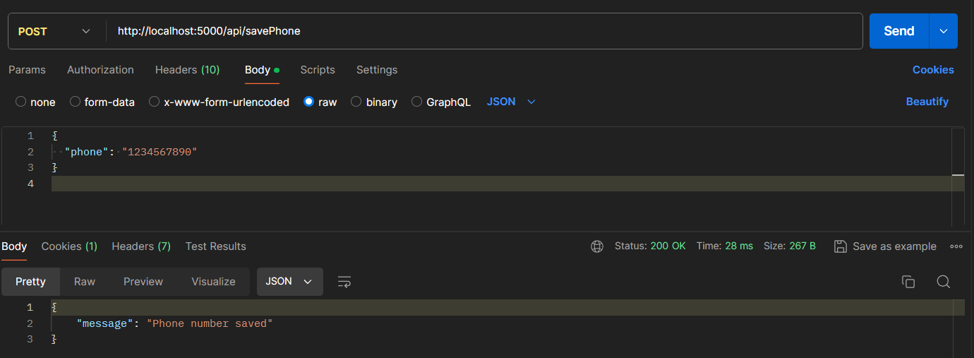

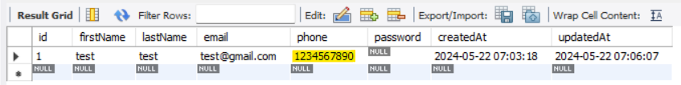

5/Testing EndPoint : POST /api/savePassword

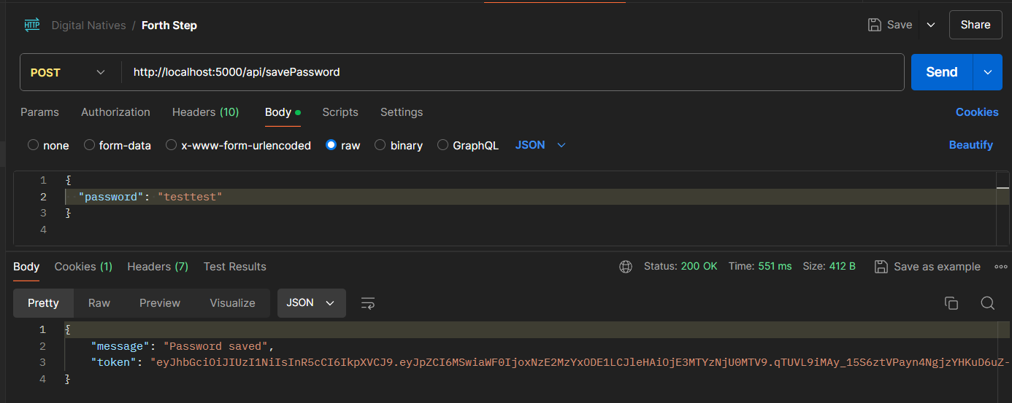

**+Generate Token**

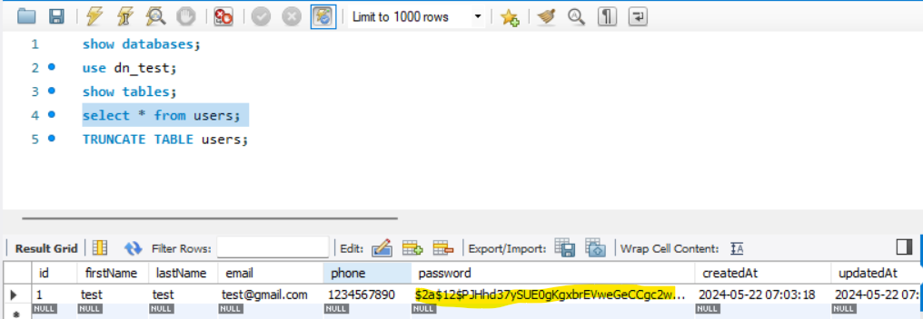

**Session destroyed and cookie cleared**

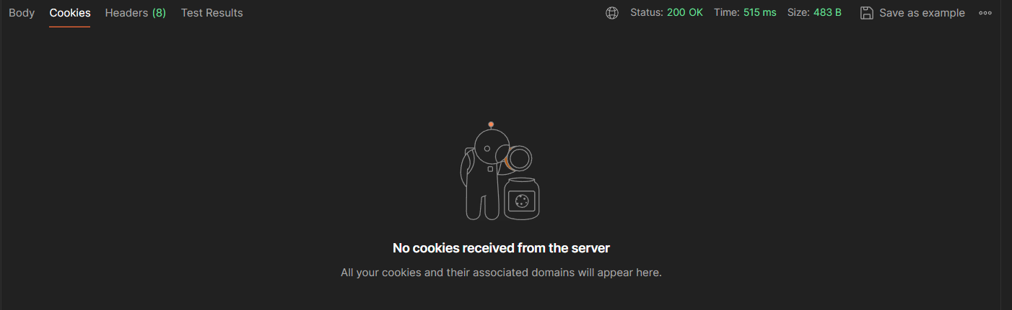

**If name already exists:** 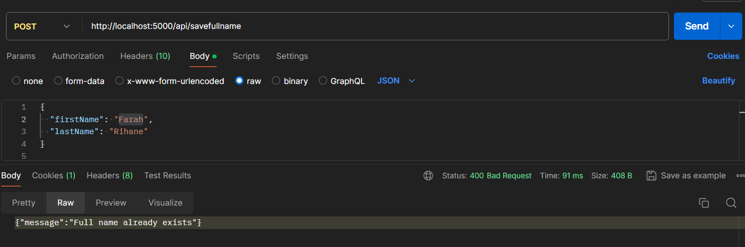

**Managed using sequelize replacements: - pass variables in the Query** 